Practical File

Session September 2022 - Feb2023

Name: - Nishi Kant Nayak
Roll Number: - 202590800142
Trade: - Computer Science Engineering
Subject: - Cloud Computing

Practical – 1
Aim: Introduction to Cloud Vendors: Amazon, Microsoft and IBM Solution
Cloud Computing:-
The term cloud refers to a network or the internet. It is a technology that uses remote servers on the internet to store, manage, and access data online rather than local drives. The data can be anything such as files, images, documents, audio, video, and more.

Cloud Vendors:-
Cloud Service providers (CSP) offer various services such as Software as a Service, Platform as a service, Infrastructure as a service, network services, business applications, mobile applications, and infrastructure in the cloud. The cloud service providers host these services in a data centre, and users can access these services through cloud provider companies using an
Internet connection.

Some Cloud Vendors are: -
- Amazon Web Services(AWS)
AWS (Amazon Web Services) is a secure cloud service platform provided by Amazon. It offers various services such as database storage, computing power, content delivery, Relational Database, Simple Email, Simple Queue, and other functionality to increase the organisation's growth.
Features of AWS:-
- AWS is scalable because it has an ability to scale the computing resources up or down according to the organisation's demand.
- AWS is cost-effective as it works on a pay-as-you-go pricing model.
- It provides various flexible storage options.
- It offers various security services such as infrastructure security, data encryption, monitoring & logging, identity and access control, penetration testing, and DDoS attacks.
- It can efficiently manage and secure windows workloads.

- Microsoft Azure
Microsoft Azure is also known as Windows Azure. It supports various operating systems, databases, programming languages, and frameworks that allow IT professionals to easily build, deploy, and manage applications through a worldwide network. It also allows users to create different groups for related utilities.
Features of Microsoft Azure:-
- Microsoft Azure provides scalable, flexible and cost effective.
- It allows developer to quickly manage applications and websites.
- It manages each resource Individually.
- Its IAAS infrastructure allows us to launch a general-purpose virtual machine in different platforms such as Windows and Linux.
- It offers a Content Delivery System (CDS) for delivering the Images, videos, audios, and applications.

- IBM Cloud Services
IBM Cloud is an open-source, faster, and more reliable platform. It is built with a suite of advanced data and AI tools. It offers various services such as Infrastructure as a service, Software as a service, and platform as a service. You can access its services like compute power, cloud data & Analytics, cloud use cases, and storage networking using internet connection.
Features of IBM Cloud Services: -
- It improves operational efficiency.
- Its speed and agility improve the customer's satisfaction.
- It offers Infrastructure as a Service (IAAS), Platform as a Service (PAAS), as well as Software as a Service (SAAS)
- It offers various cloud communications services to our IT environment.

Practical – 2
Aim: - Setting up virtualization using virtual box / vm hypervisor
Enable CPU Virtualization features
First, you need to enable hardware virtualization features on your CPU(Central Processor Unit) such as Intel VT-X or AMD-V in UEFI/BIOS of your physical computer. Otherwise, if you run 64-bit guest operating systems, you can get the error: VT-x is not available. If Hyper-V is installed on your Windows machine, uninstall Hyper-V before installing VirtualBox (otherwise Hyper-V will block hardware virtualization extensions needed by VirtualBox to run VMs). The majority of modern processors support hardware virtualization.

Setting up the Virtualbox
- Download the Virtualbox from its official website i.e. https://virtualbox.org
- Click the Download button and select the platform packages
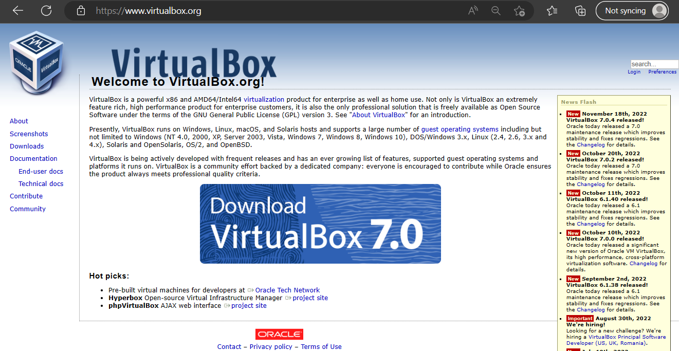
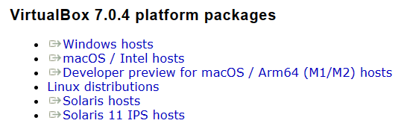
- Start the .exe file downloaded from net to begin the installation
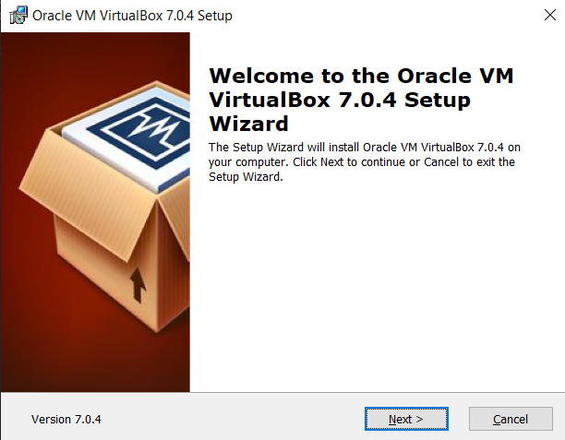
- Follow up the Next button
- Select the storage Location and Click the Next button

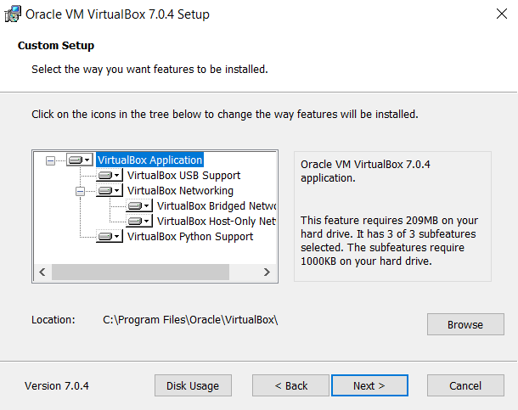

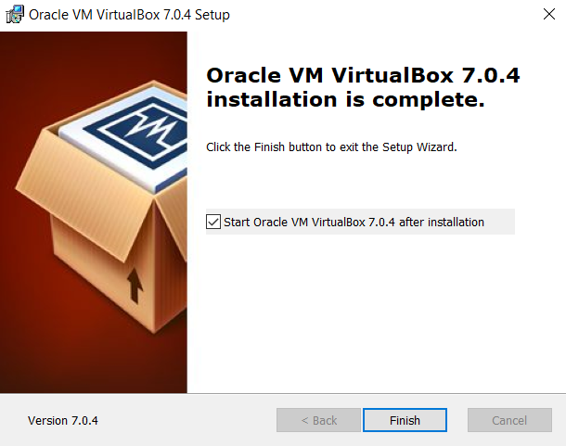

- Installation completed
Creating a Virtual Machine
- Click on the New Button present under the Machine section or use New button with Blue Star to create a new Virtual Machine in virtualbox GUI.
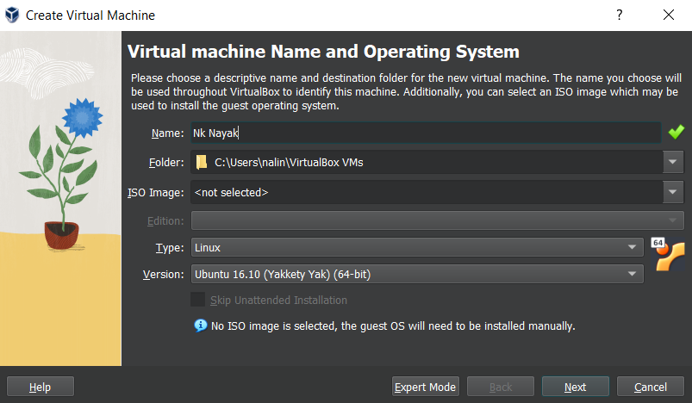

- Setup the RAM for Virtual Devices
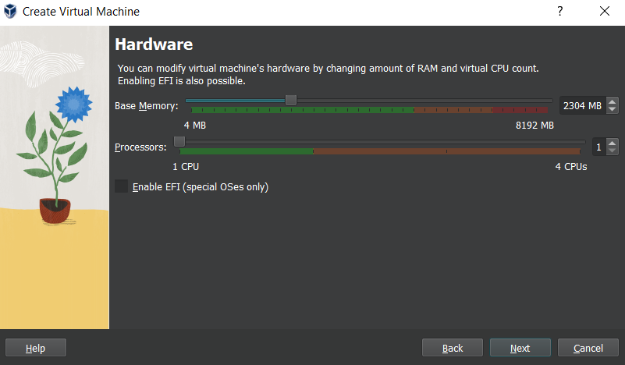
- Manage the disk space required
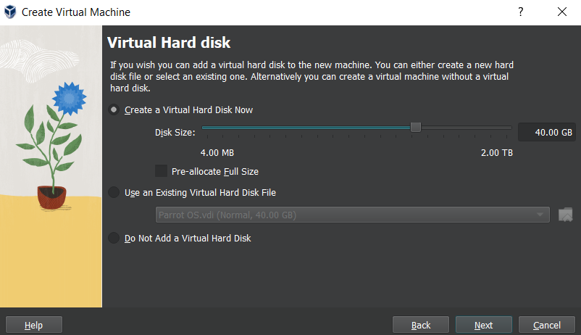

- Finalize the information of the Virtual Machine and click the Finish button
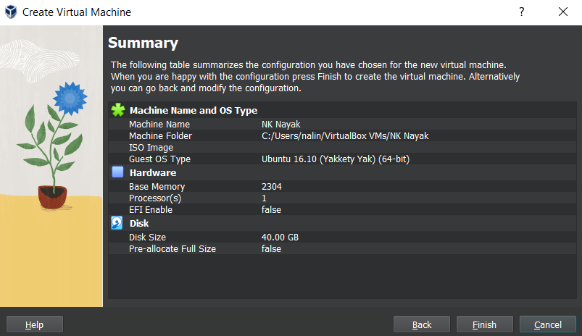
- Machine is ready and click on the Start button
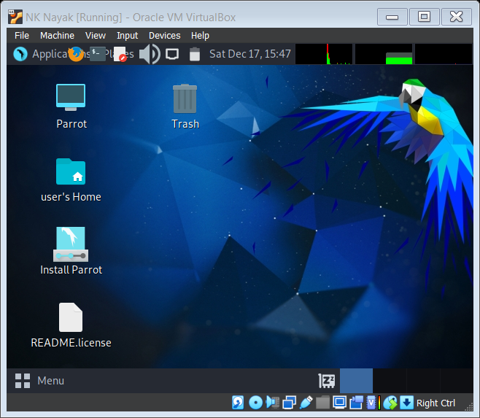

Practical – 3
Aim:- Introduction to Own Cloud.
- Introduction
Welcome to own Cloud: your self-hosted file sync and share solution. Own Cloud is an open source file sync and share software for everyone from individuals operating the free own Cloud Server edition, to large enterprises and service providers operating the own Cloud Enterprises subscription. Own Cloud Provides a safe, secure, and compliment file synchronization and sharing solution on servers that you control.
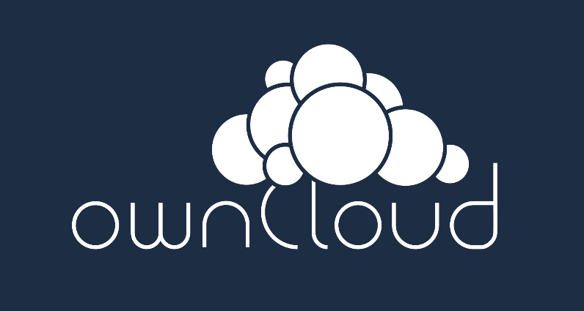
You can share one or more files and folders on your computer \, and synchronizes them with your own cloud. Place files in a local share directories, and those files are immediately synchronize to the server and the other devices using the owncloud Desktop Sync, client, Android App, or IOS App.
- History
- The Development of the owncloud was announced in January 2010, in order to provide a free software replacement to proprietary storage service provider. The company was found in 2011 and forked the code away from KDE(K Desktop Environment) to GitHub.
- OwnCloud Inc. the company founded by Markus Rex, Holger Dyroff and Frank Karlitschek, has attracted funding from investors, including an injection og 6.3million US$ in 2014.
- In April 2016, Karlitschek left owncloud Inc. and founded a company and project called NextCloud in June 2016, resulting in the closure of OwnCloud Inc. Some former owncloud Inc. develops left ownCloud GmbH, based Numerberg Germany, secured additional financing, and expanded its management team.
- In July 2016, ownCLoud, based in Numerberg Germany, secured additional financing and expanded its management team.
- In 2018, owncloud launched its own SAAS offer for small businesses and NGOs. The service aimed to provide a secure and GDPR- compatible solution for organization without their own IT Department.
- In October 2018, for the 3rd Time in a row, ownCloud GmbH received the IT Awards, which is based on the vote of over 30,000 business users for their best of choice Enterprise File Sync and Share Solution.
- In March 2019, ownCloud launched the BayrenBox in cooperation with the Bavarian state office for Survey and Geoinformation, an ownCloud-based collaboration solution for the Bavarian municipalities. The Development involves one ownCloud instances for each over 2000 municipalities.
- To bring a architecture of the iOS app up-to-date with the state technology, in June 2019 ownCloud released a complete rewrite of its iOS app. It had a Strong Focus on security and made use of many iOS integration features for improved usability Unlike the old app, it was released free of charge.
- Feature
- Owncloud is software product only. Owncloud does not offer off-premises storage capacity. This is in contrast to the likes of DropBox that offers both software and off-premises storage capacity.
- OwnCloud files are stored in conventional directory structures and can be accessed via WebDAV if necessary. User Files are encrypted both at rest and during transit. ownCloud can synchronize with local clients running Windows(Windows XP, Windows Vista, Windows 7 and Windows 8)., macOS(10.6 or later), or various Linux distributions.
- OwnCloud users can manage calendars (CalDAV), contacts (CardDAV) schedule tasks and streaming media(Apache) from within the platform.
- From the administrative perspective, ownCloud permits user and group administration (via Open ID or LDAP). Content can be shared by defining granular read/write permission between users and/or groups. Alternatively, ownCloud users can create public URLs when sharing files. Logging of file-related actions is available in the enterprise and education service offerings.
- Furthermore, users can interact with the browser-based ODF-Format word processor, [18] bookmarking service, URL shorting suite, gallery, RSS feed reader and document viewer tools from within ownCloud. For additional extensibility, ownCloud can be augmented with “one-click” application and connection to DropBox and Google Drive and Amazon S3.
- All ownCloud clients (Desktop, iOS, Android) support the OAuth 2 standard for Client Authentication

Practical – 4
Aim :- Installation and configuration of ownCloud software for SAAS
What makes own cloud different?
The one thing that sets ownCloud apart is that it’s open source and freely available to anyone who wants to set up ownCloud on a local server. The open source nature of ownCloud means that there is a community ready to help with any issue that you might encounter. The app store is one of the most important aspects of ownCloud, with a wide variety of apps that let you personalise your cloud.

System Requirements :-
- ownCloud can run with a minimum of 128MB of RAM, but 512 is recommended.
- Ubuntu 14.04 LTS+ or Debian 7+
- MySQL/MariaDB
- PHP 5.4+
- Apache 2.4 with mod_php
Setup and configuration
The ownCloud server package is not available within Ubuntu’s default repositories. However, ownCloud maintains a dedicated repository for Ubuntu 16.04. A release key should be added to apt and the repo link should be specified in the sources.list file to install ownCloud and its dependencies.

To add the release key, download it using wget and import it using the apt-key command, as follows:
- $wget –nv https://download.owncloud.org/download/repositories/9.1/Ubuntu_16.04/Release.key -O Release.key
- $sudo apt-key add -< Release.key

The ‘Release.key’ is an encrypted public key which apt will use to verify the authenticity of ownCloud packages. In addition to that, add the ownCloud repository in a file called
owncloud.list and save it in the sources.list.d folder as shown below:

- $sudo sh –c “echo ‘deb http://download.owncloud.org/download/repositories/9.1/Ubuntu_16.04/ /’ >> /etc/apt/sources.list.d/owncloud.list”

Use the apt-get update command to make apt aware of the change, as follows:
- $sudo apt-get update
Install the LAMP(Linux, Apache, MySQL, PHP)Server:
- $sudo apt-get install lamp-server
You will automatically prompted with a window to create a password for the MySQL root user. Enter a secure password, and use the tab key and the space bar to select the OK button.
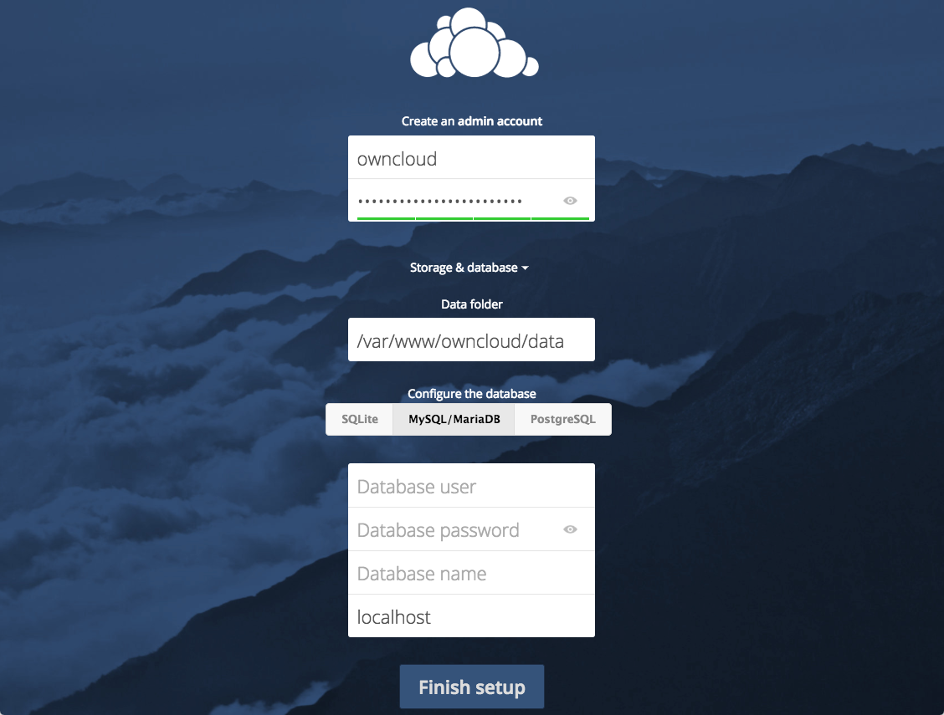

Add a MySQL Database
The Next step is to create a MySQL database for ownCloud. Log in to MySQL by using the following command:
mysql –defaults-file/etc/mysql/debian.cnf
This opens up the MySQL command line prompt. Enter the following SQL commands to create a user with the name ‘owncloud’ and a database of the same name. Replace the word ‘mysecurepassword’ with your own password in the commands, as shown below:
- Create Database ownCloud;
- Create user owncloud@localhost IDENTIFIED BY ‘mysecurepassword’;
- GRANT all privilages on ownCloud. * TO ownCloud@localhost;
- flush privilages;
- quit
Install ownCloud using the apt-get install command. The ‘owncloud’ package will install all the required dependencies.
- $sudo apt-get install ownCloud
Restart the apache server to update the changes made to apache’s config directory.
- $sudo service apache2 restart

A quick start and setting up the account of admin
- Open the web interface of ownCloud by navigating to http://localhost/owncloud/.
- If ownCloud is hosted in the server, you can get to the web interface using the server domain or the IP address of the server (https://server_domain_or_IP/owncloud).
- If a self-signed certificate is being used, you are likely to be presented with the warning because the certificate is not signed by one of your browser’s trusted authorities. This is expected and normal. We are only interested in the encryption aspect of the certificate, not the third-party validation of our host’s authenticity. Click the appropriate button or link to proceed to the ownCloud admin page.
- When the page loads, you will be prompted with a form to enter a user name (for security reasons, it is recommended that you do not use admin as the user name)
and password to create an admin account.
- The default database used by ownCloud is SQlite, which should not be used in production. To change it to MySQL, click on the Storage & database link. Leave the Data folder settings as they are and click on the MySQL/MariaDB tab to use MySQL. Enter the database information that you configured while installing the LAMP server.
- Click on the Finish setup button to create the admin user and log in. A splash screen with the words, ‘A safe home for all your data’ should appear.
- Close the splash screen to access the main interface. Here, you can create or upload files to your personal cloud. Share files with others, view the files shared with you and share files via links.

Extending ownCloud with apps
ownCloud has a rich ecosystem of apps, which provide access to a variety of functionality. Usually, an app offers a distinct function like a mail client or music player, but even core functionalities of ownCloud, like sharing and external storage, are implemented as apps. A large selection of apps is available at apps.owncloud.com and if you want to install one that is not available in the app manager, you can download it from the app store and install it by hand (this process is manual because there is a risk associated with downloading and running
Code from the Internet).

Practical – 5
Aim: - Accessing Microsoft AZURE cloud-services
Set up the development environment
To start, set up your development environment with Visual Studio and the Azure SDK.
- Visual Studio 2019 includes the Azure SDK. If you're using Visual Studio 2019, no additional setup is needed for the development environment.
- For Visual Studio 2015, click the following link to install the Azure SDK for Visual Studio 2015.
- For Visual Studio 2013, click the following link to install the Azure SDK for Visual Studio 2013.
- If you don't have Visual Studio installed, use the following to install Visual Studio 2019 with the Azure SDK.
Download and run the completed solution
- Download and unzip the completed solution.
- Start Visual Studio.
- From the File menu choose Open Project, navigate to where you downloaded the solution, and then open the solution file.
- Press CTRL+SHIFT+B to build the solution.
- By default, Visual Studio automatically restores the NuGet package content, which was not included in the .zip file. If the packages don't restore, install them manually by going to the Manage NuGet Packages for Solution dialog box and clicking the Restore button at the top right.
- In Solution Explorer, make sure that ContosoAdsCloudService is selected as the startup project.
- If you're using Visual Studio 2015 or higher, change the SQL Server connection string in the application Web.config file of the ContosoAdsWeb project and in the ServiceConfiguration.Local.cscfg file of the ContosoAdsCloudService project. In each case, change "(localdb)\v11.0" to "(localdb)\MSSQLLocalDB".
- Press CTRL+F5 to run the application.
- Click Create an Ad.
- Enter some test data and select a .jpg image to upload, and then click Create.
The app goes to the Index page, but it doesn't show a thumbnail for the new ad because that processing hasn't happened yet.
Wait a moment and then refresh the Index page to see the thumbnail.
Click Details for your ad to see the full-size image.
You've been running the application entirely on your local computer, with no connection to the cloud. The storage emulator stores the queue and blob data in a SQL Server Express LocalDB database, and the application stores the ad data in another LocalDB database. Entity Framework Code First automatically created the ad database the first time the web app tried to access it.
Deploy the application to Azure
You'll do the following steps to run the application in the cloud:
- Create an Azure cloud service.
- Create a database in Azure SQL Database.
- Create an Azure storage account.
- Configure the solution to use your database when it runs in Azure.
- Configure the solution to use your Azure storage account when it runs in Azure.
- Deploy the project to your Azure cloud service.
Create an Azure cloud service
- An Azure cloud service is the environment the application will run in.
- In your browser, open the Azure portal.
- Click Create a resource > Compute > Cloud Service.
- In the DNS name input box, enter a URL prefix for the cloud service.
- This URL has to be unique. You'll get an error message if the prefix you choose is already in use.
- Specify a new Resource group for the service. Click Create new and then type a name in the Resource group input box, such as CS_contososadsRG.
- Choose the region where you want to deploy the application.
- This field specifies which datacenter your cloud service will be hosted in. For a production application, you'd choose the region closest to your customers. For this tutorial, choose the region closest to you.
- Click Create.
In the following image, a cloud service is created with the URL CSvccontosoads.cloudapp.net.

Create a database in Azure SQL Database
- When the app runs in the cloud, it will use a cloud-based database.
- In the Azure portal, click Create a resource > Databases > SQL Database.
- In the Database Name box, enter contosoads.
- In the Resource group, click Use existing and select the resource group used for the cloud service.
- In the following image, click Server - Configure required settings and Create a new server.
- Alternatively, if your subscription already has a server, you can select that server from the drop-down list.
- In the Server name box, enter csvccontosodbserver.
- Enter an administrator Login Name and Password.
- If you selected Create a new server, you aren't entering an existing name and password here. You're entering a new name and password that you're defining now to use later when you access the database. If you selected a server that you created previously, you'll be prompted for the password to the administrative user account you already created.
- Choose the same Location that you chose for the cloud service.

- When the cloud service and database are in different datacenters (different regions), latency will increase and you will be charged for bandwidth outside the data center. Bandwidth within a data center is free.
- Check Allow azure services to access server.
- Click Select for the new server.
- Click Create

Create an Azure storage account
An Azure storage account provides resources for storing queue and blob data in the cloud.
In a real-world application, you would typically create separate accounts for application data versus logging data, and separate accounts for test data versus production data. For this tutorial, you'll use just one account.
- In the Azure portal, click Create a resource > Storage > Storage account - blob, file, table, queue.
- In the Name box, enter a URL prefix.
- This prefix plus the text you see under the box will be the unique URL to your storage account. If the prefix you enter has already been used by someone else, you'll have to choose a different prefix.
- Set the Deployment model to Classic.
- Set the Replication drop-down list to Locally redundant storage.
- In the Resource group, click Use existing and select the resource group used for the cloud service.
- Set the Location drop-down list to the same region you chose for the cloud service.
- When the cloud service and storage account are in different datacenters (different regions), latency will increase and you will be charged for bandwidth outside the data center. Bandwidth within a data center is free.
- Azure affinity groups provide a mechanism to minimize the distance between resources in a data center, which can reduce latency. This tutorial does not use affinity groups. For more information, see How to Create an Affinity Group in Azure.
- Click Create.
In the image, a storage account is created with the URL csvccontosoads.core.windows.net.
Configure the solution to use your database in Azure SQL Database when it runs in Azure
The web project and the worker role project each has its own database connection string, and each needs to point to the database in Azure SQL Database when the app runs in Azure.
- • In the ContosoAdsWeb project, open the Web.Release.config transform file for the application Web.config file, delete the comment block that contains a <connectionStrings> element, and paste the following code in its place.

XML
<connectionStrings>
<add name="ContosoAdsContext" connectionString="{connectionstring}"
providerName="System.Data.SqlClient" xdt:Transform="SetAttributes" xdt:Locator="Match(name)"/>
</connectionStrings>
Leave the file open for editing.
- In the Azure portal, click SQL Databases in the left pane, click the database you created for this tutorial, and then click Show connection strings.
The portal displays connection strings, with a placeholder for the password.

- In the Web.Release.config transform file, delete {connectionstring} and paste in its place the ADO.NET connection string from the Azure portal.
- In the connection string that you pasted into the Web.Release.config transform file, replace {your_password_here} with the password you created for the new SQL database.
- Save the file.
- Select and copy the connection string (without the surrounding quotation marks) for use in the following steps for configuring the worker role project.
- In Solution Explorer, under Roles in the cloud service project, right-click ContosoAdsWorker and then click Properties.
- Click the Settings tab.
- Change Service Configuration to Cloud
.

- Select the Value field for the ContosoAdsDbConnectionString setting, and then paste the connection string that you copied from the previous section of the tutorial.

- Save your changes.

Configure the solution to use your Azure storage account when it runs in Azure
Azure storage account connection strings for both the web role project and the worker role project are stored in environment settings in the cloud service project. For each project, there is a separate set of settings to be used when the application runs locally and when it runs in the cloud. You'll update the cloud environment settings for both web and worker role projects.
- In Solution Explorer, right-click ContosoAdsWeb under Roles in the ContosoAdsCloudService project, and then click Properties.
- Click the Settings tab. In the Service Configuration drop-down box, choose Cloud.
- Select the StorageConnectionString entry, and you'll see an ellipsis (...) button at the right end of the line. Click the ellipsis button to open the Create Storage Account Connection String dialog box.
- In the Create Storage Connection String dialog box, click Your subscription, choose the storage account that you created earlier, and then click OK. If you're not already logged in, you'll be prompted for your Azure account credentials.
- Save your changes.
- Follow the same procedure that you used for the Storage Connection String connection string to set the Microsoft Windows Azure Plugins Diagnostics Connection String connection string.
- This connection string is used for logging.
- Follow the same procedure that you used for the ContosoAdsWeb role to set both connection strings for the ContosoAdsWorker role. Don't forget to set Service Configuration to Cloud.

Deploy the project to Azure
- In Solution Explorer, right-click the ContosoAdsCloudService cloud project and then select Publish.
- In the Sign in step of the Publish Azure Application wizard, click Next.
- In the Settings step of the wizard, click Next.

- The default settings in the Advanced tab are fine for this tutorial. For information about the advanced tab, see Publish Azure Application Wizard.
- In the Summary step, click Publish.

- The Azure Activity Log window opens in Visual Studio.
- Click the right arrow icon to expand the deployment details.
- The deployment can take up to 5 minutes or more to complete.
- When the deployment status is complete, click the Web app URL to start the application.
- You can now test the app by creating, viewing, and editing some ads, as you did when you ran the application locally.

